**Java Tutorial for Beginners**

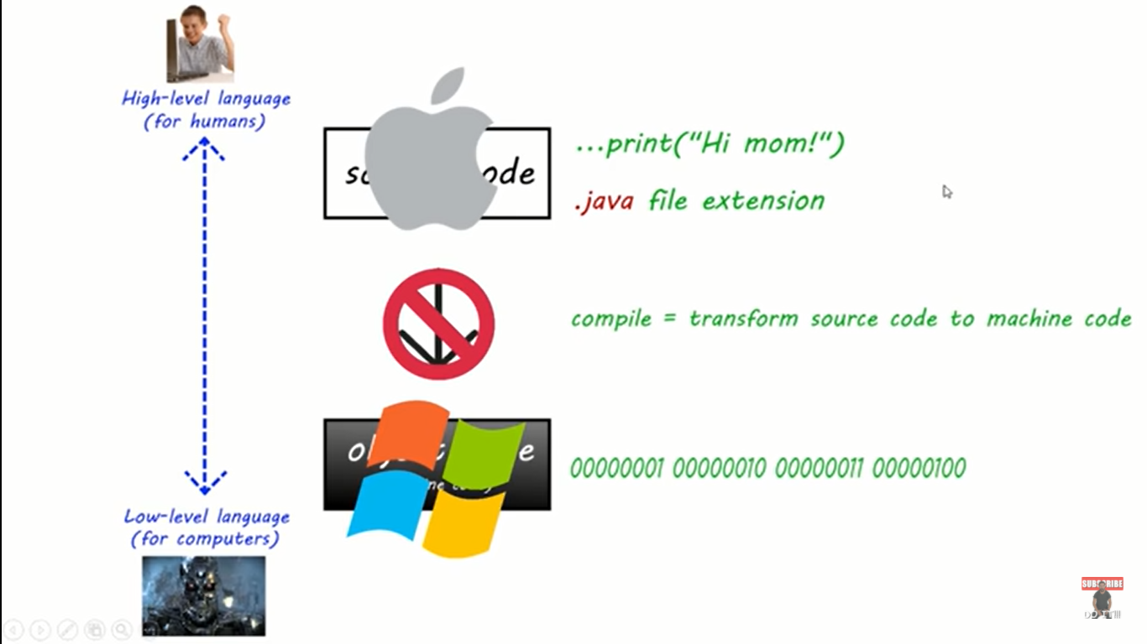

When we compile our source code to machine code it’s machine specific. If we write source code and compile on a Mac we can only run that code on Mac not in Windows, linux or other OS.

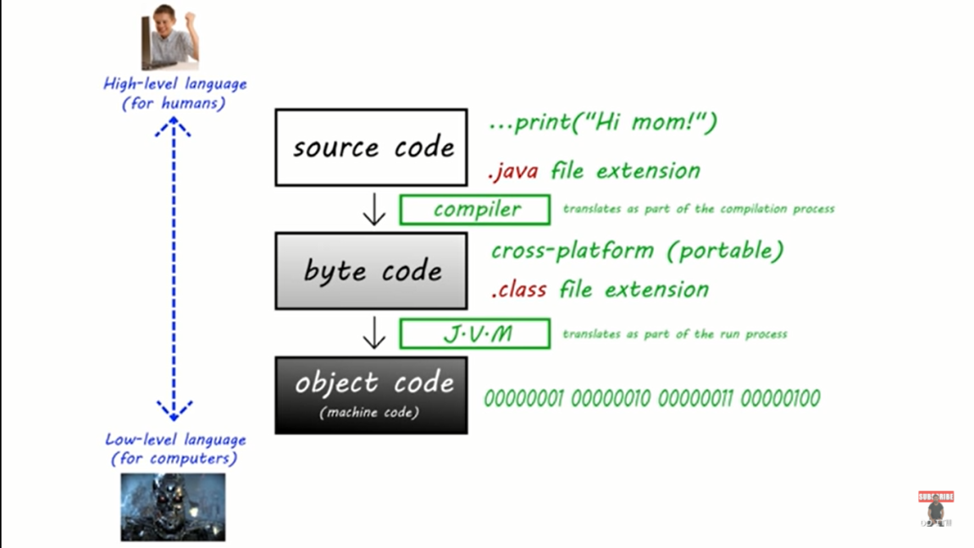

Although The java language has a solution for this problem. With java we’ve an intermediary step, Where we can compile our source code to a format called byteCode.  
Bytecode is cross platform and ends with a .class (dot class) file extension. Since, bytecode is cross-platform you could write your code on a mac and then send your bytecode file to your friend who can then run it on their pc using a jvm to translate the bytecode to machine code.

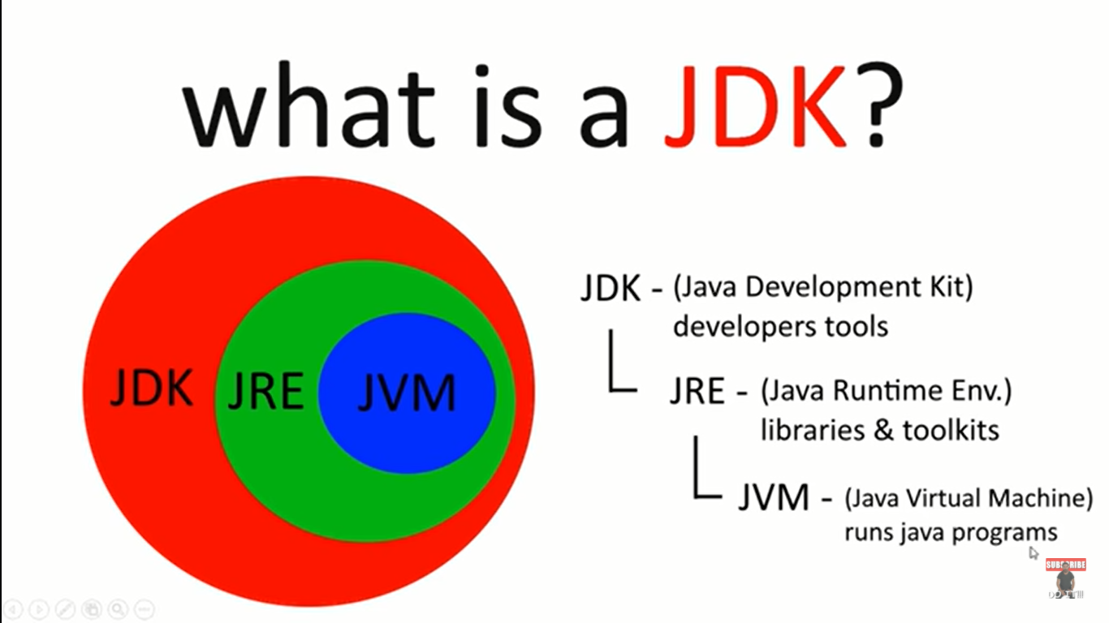

**JVM** included with a JDK. **JDK** is an acronym for *Java Development Kit*. It contains developer tools to help us code as well as a **JRE** a *Java Runtime Environment* which contains a library & tools and our JVM which is another acronym for *Java Virtual Machine* which translates by code for us to machine code.

**What is an IDE?**

I – Integrated

D – Development

E – Environment

(software that helps us write software)

Basically, IDE provide an interface for us to write code and check fro errors compile and run code.

There are 2 common IDE for JAVA are:-

* Eclipse
* Intellij Idea

**Note:**

* To configure the JRE, the Java Runtime Environment that we downloaded that the JDK because the JRE component of the JDK . So we’ve to check the current downloaded or updated verion of JDK that we have.

After created the project, We’ve to add class to this project. Class is collection of related code.   
So, in order to add a class to the project:

1. Select the project folder
2. Go to file 🡪 New 🡪 Class
3. Then we’ve to give a unique name to this class. Ex: Main. (First letter should be in UpperCase). And below down we’ve to check ***public static_void main(String[] args)*** then justclick finish button.
4. Now we’ve to take a look back within our project folder and it should now have a java file (.java file) share the same name as you class name. (Ex: Main.java). So, this what .java extension file is a source code. All the class is collection of related code.  
   The first class   
     
   The code under the java file is the format that humans can easily read and understand and when we compile this source code to bytecode we’re going to create a new file that hast the .class (dot class) file extension and with that bytecode file we can run that and translate it using a JVM(Java Virtual Machine)

Anything within the block {} of main class belong to this main class and within our Main class we’ve what is called main method.  
 **public** **static** **void** main(String[] args) {

}

Our program won’t run without this method because when we run our code we begin by calling the main method.